**Travel Memory Assignment –**

* Launch an EC2 instance and use the below command to connect to the instance.

* **ssh -i <pem name (TM.pem)> ubuntu@<public_ip_address>**

* Install Nginx using the below command.

* **sudo apt install nginx**

* Install Nodejs on the EC2 instance using the below commands

* **curl -sL https://deb.nodesource.com/setup_18.x -o /tmp/nodesource_setup.sh**

* **sudo bash /tmp/nodesource_setup.sh**

* **sudo apt install nodejs**

* Clone the Travel Memory project from the below repository.

* **git clone** [**https://github.com/UnpredictablePrashant/TravelMemory**](https://github.com/UnpredictablePrashant/TravelMemory)

* Process to Run the Backend

* Create a .env file in the backend and add the relevant port number and mongodb url to the file. 

* Perform npm install
* Navigate to the frontend and edit the url.js 
* Perform npm install
* Nginx configuration

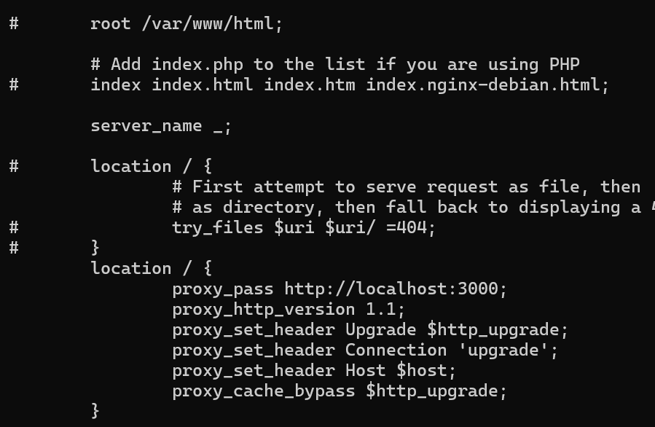

* Configure the inbound rules for the instances.

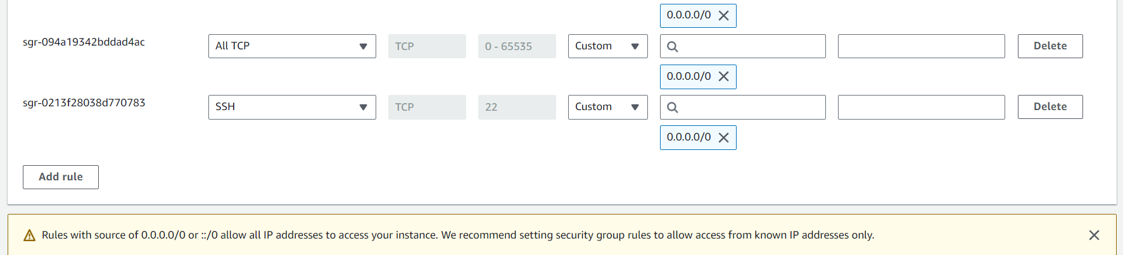

* Setup an application load balancer with relevant target groups selected.

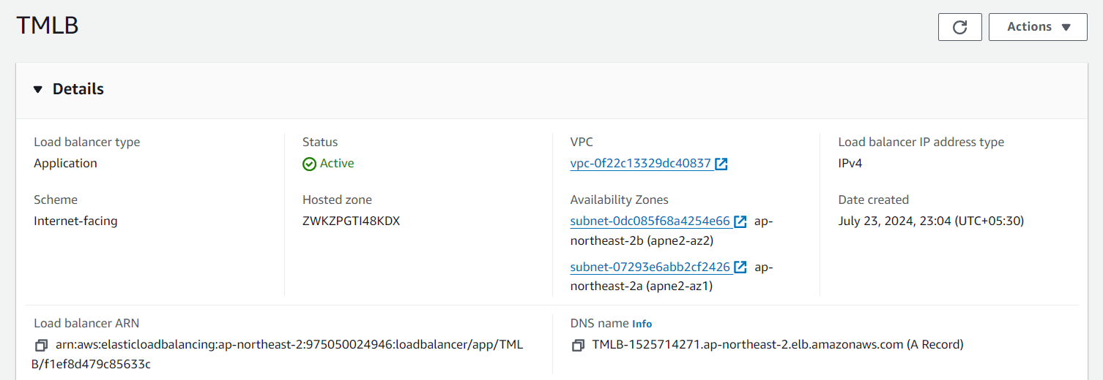

* Configure the cloudflare create a CNAME and fill the name of your choice and paste dns name with content copied from loadbalancer.

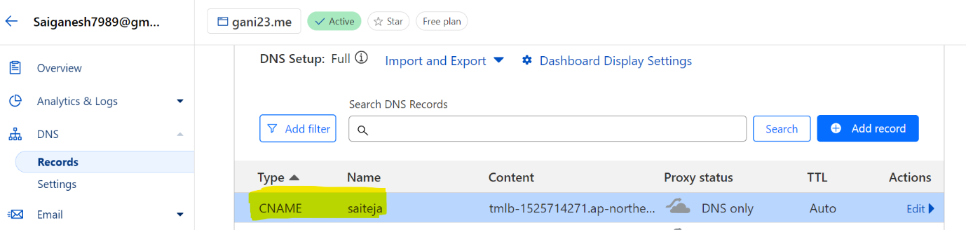

* Run the backend and frontend using below respective commands.

*node index.js

*npm start

**Backend**

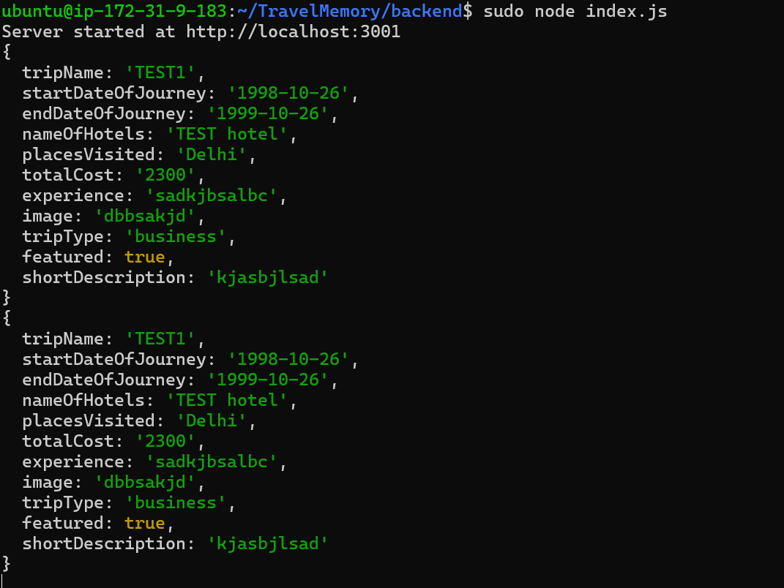

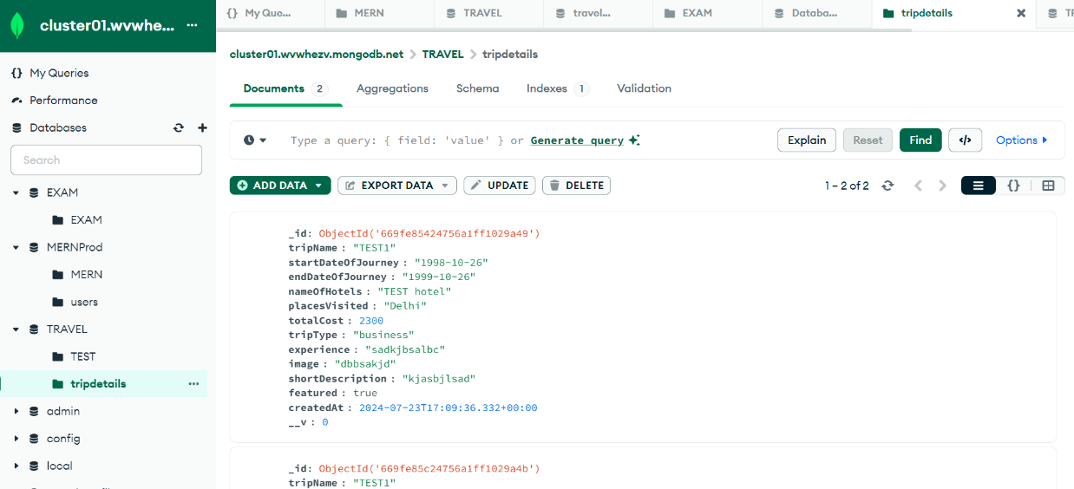

**Frontend**

